**NSCI 20100 Neuroscience Laboratory**

**Crayfish Stretch Receptor**

**BSLC 322, January 23 & 25, 2019**

**Goals:** In this lab, you will record action potentials from a single neuron, the stretch receptor in the tail of the crayfish. You will measure the amplitude, duration and rate of action potentials while applying stimuli of different intensities to the tail. You will gain experience with signal conditioning and methods for reducing electrical noise in low voltage recordings.

**Safety:** You will be working with sharp instruments during the dissection. Be careful to avoid any scratches or cuts, and report any injuries to the instructors. No personal protective equipment (PPE) is required, but you may prefer to wear gloves while handling the crayfish.

**Reading:** Before the lab, you should read the introduction and discussion of the overview article by Leksrisawat et al (2010) which you will find on the Canvas site. We will be using a different dissection that Leksrisawat, however.

**Data:** As in previous labs you will use a Matlab-based application for data collection. It will save plots that list relevant parameters

**Clean up:** When you have finished, you should dispose of any animal parts as instructed. Surgical instruments should be gently cleaned in soapy water, rinsed with deionized water, and left to air dry on the paper on which you found them. The suction electrode should be cleaned by loading the syringe with a few milliliters of deionized water and passing it slowly out through the tip. This should be followed by pushing a few milliliters of air through the tip. The dish that holds the specimen should be rinsed with deionized water, covered with foil or plastic wrap and left on your rig. The electronic equipment should be returned to the disassembled state in which you found it.

**Lab Report:** Lab reports should be prepared following the general instructions found on the course Canvas site. In preparing your report, you might consider some of the following:

*Introduction:* Why are crayfish a good subject for nerve recording? What advantages are there to suction electrodes? How does extracellular recording work?

*Methods:* Describe the procedures that were used. Be sure to include all parameters related to filtering and amplification of your signals.

*Results:* If possible, include a photograph of action potentials you recorded. Be sure to report the amplitude and duration of the action potential. If you recorded sensory responses, report the highest rate of firing that you obtained. You might be tempted to include a video of action potentials. Please read the page on Videos in Lab Report, which you can find in the Crayfish module on the Canvas site.

*Discussion:* Discuss factors that might influence seeing larger or smaller action potentials, explaining how they would affect the signal.

**Laboratory Procedures**

***Hardware Setup:***You should set up your hardware and make sure you have acceptable electrical noise levels before collecting crayfish. Most of the hardware and cabling will need to be configured. You should find the suction electrode in the micromanipulator on the rig. It should be connected to the C-ISO-256 using the cable provided. The connections to the suction electrode include one large pin and two small pins. The green pin (or the one with the bare wire) should be inserted into the socket marked with a tiny green “G”. This is the shielding ground. The other small pin (black) is the signal ground). Follow the color coding for the connections to the C-ISO-256. Make sure the small switch on the C-ISO-256 is set to 2.5 kHz. Remember that the C-ISO-256 performs a fixed 400x amplification on all your signals.

The cable from the C-ISO-256 should be connected to left input of the iWorx ETH-256 amplifier (Channel 1). The initial settings for Channel 1 on the iWorx amplifier should be: “3 Hz” HPF (high-pass filter); “2 kHz” LPF (low-pass filter); and “x10” gain. The settings are indicated by small red LEDs, and are changed by pressing the appropriate black button. You may change these settings to improve the quality of your data. The settings for Channel 2 are irrelevant.

Use a BNC cable to connect Output 1 of the ETH-256 to a LabJack U6 computer data acquisition unit. A BNC-to-wire adaptor will need to be installed to the LabJack’s analog input channel 0 (AIN0, red wire) and analog ground (GND, black wire) inputs (using a screwdriver). The LabJack U6 should be connected to the iMac computer with a USB cable.

**Software and Signal Assessment:** Before preparing your crayfish, you should make sure you have a good recording configuration with low noise. Fill the dish halfway with crayfish ringers (which is in a carboy in the fridge). Place it under the suction electrode and pivot the electrode until its tip is in the ringers. Gently pull ringers into the electrode until it covers the end of the electrode wire inside the electrode. You don’t need to cover more than the end of the wire. Turn on the amplifier.

You will use a Matlab application to collect your data. The necessary software is installed and configured on each of the lab’s computers. Use the following procedures to run the software.

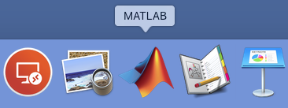1) Log into the “labuser” account. There is no password for this account: Do not enter anything in the password field.

2) Launch Matlab by clicking on the Matlab icon in the dock at the bottom of the display. (Matlab might have a date appended to its name, such as “Matlab_2017a”.)

3) When it launches, Matlab will display a large, multi-paneled window. You will first measure your 60 Hz noise using an application called “StretchReceptor” (no space), which you can launch by typing its name in the Matlab “Command Window” at the bottom of the Matlab window.

4) The StretchReceptor application will take several seconds to launch. Once it has finished launching, you will see a new window as shown below. When you press the **Start** button, it should begin display the analog signal from the suction electrode. You can adjust the speed and gain of the trace using the pop-up menus to the right of the control window. You will probably want to use a 250 Hz high-pass filter while collecting data, but you should start with a setting of 1 Hz.

5) You should use this display to minimize the 60 Hz noise (16.7 ms period) on the signal. With a well-configured rig, you should be able to record action potentials with an amplitude of 50 to 100 µV (pre-amplification). You should strive to get your 60 Hz noise below ~10 µV peak-to-peak. Try different configurations until the noise is acceptable. Ask an instructor to look at your noise before you prepare your crayfish.

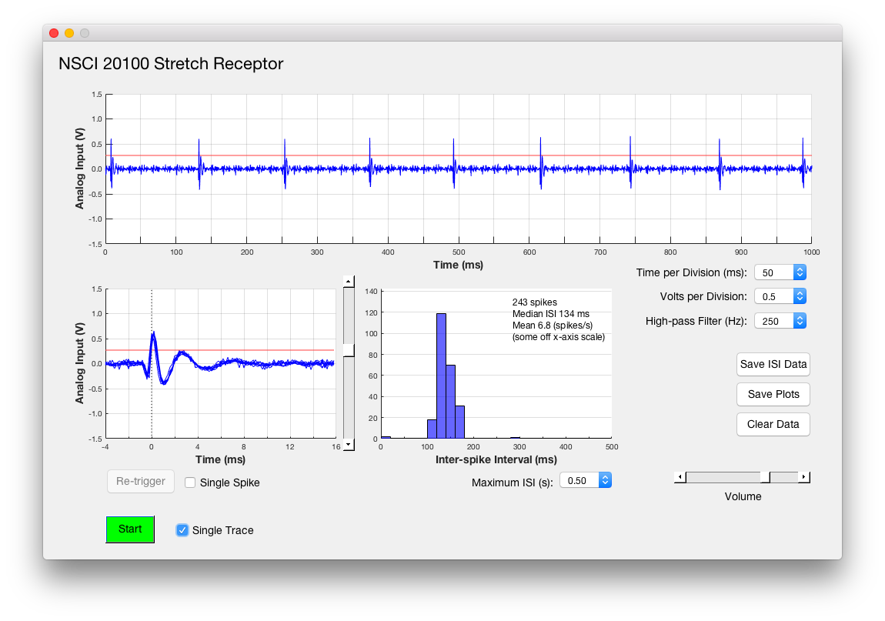**Crayfish Preparation:** Prepare you crayfish as instructed in the lecture. Remember to insert a thread in the tail (telson). Pin the tail in the dish using the small pins provided. The following may be helpful to you:

• Take your time.

• Your results will be much better if you make the effort to get a good field of view with good lighting

• Adjust your magnification, focus and lighting as you work on different parts of the prep

• It is generally easier to move the dish than to move the electrode or the microscope

• It is generally easier to move the electrode than to move the microscope

• Nerves are easier to see when they move. Gently moving the dish will make nerves move

• You need nerve 2. Nerve 1 contains no stretch receptors

• Only a few of the nerves may survive the dissections

• It is helpful to rotate the dish so the nerve on the side of the tail further from the electrode mount

**Recording Data:** When you have action potentials, use the vertical slider to the right of the lower voltage plot to set a threshold for triggering spikes (the red line). The application will add a spike to the display every time the voltage crosses this line (in a direction away from zero volts). The threshold level is also plotted in red on the upper (continuous) voltage trace. The triggered plot display will be cleared every time a new trace begins in the upper (continuous) voltage trace.

If you want to see a single spike, rather than superimposed spikes, the “**Single Spike**” button will disable the adding of additional spikes. When “**Single Spike**” is enabled, the “**Re-trigger**” button allows you to plot a new single spike. The “**Single Trace**” will stop data collection after one complete trace has been collected in the upper plot.

The Inter-Spike Interval (ISI) plot displays a distribution of ISIs collected since the last time the data were cleared using the “**Clear Data**” button. It displays the following statistics (based on spikes that crossed the triggering threshold since the las time you cleared the data); the number of spikes; the median of the spike ISIs, the 25th and 75th quartiles of the ISI distribution. The standard deviation of the ISI distribution (this value can appear very large if you didn’t clear the data when you first started recording spikes); the mean spike rate corresponding to the ISI distribution. If some ISI values are larger than the maximum interval displayed, the display will show “(some off x-axis scale)”. The “**Save ISI Data**” button allows you to create a Matlab data file that lists all the current ISI values.

**Clean up:** When you have finished collecting and saved your data, you can terminate the StretchReceptor application by either 1) closing the StretchReceptor control panel window using its close button (red button in the upper left corner), 2) closing the Matlab window using its close button, or 3) making Matlab quit using Quit in the File Menu (or the keyboard equivalent, command-Q). In any case, you will be asked whether you are sure you want to quit. All unsaved data will be lost when you quit.

You should clean up following the instructions on the first page of the guide.